IFG Explore 1st Year
Term Four – Week Five Christmas Spiritual
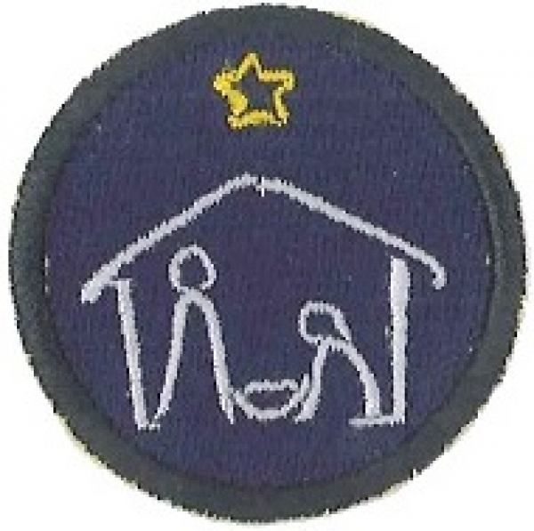
Aim: The Aim of this module is share the Christmas message with the girls and celebrate the birth of Jesus Christ

Objective:
- Continue to focus on Christmas and the birth of Jesus.

Preparation:
- Games equipment as required.
- Props for devotions
- CD player and CD’s for Christmas songs
- Candy canes – enough for two for each girl
- Wiggly eyes
- Pipe cleaners
- Copies of the meaning of the candy cane

Pre Set-Up:
Have a leader organise some Christmas games – see games section.

SetUp:
This is your usual formal start to the evening programme; girls will assemble at the Home Zone for marking the roll etc.

Devotions:
Teach the children:
(This devotion mixes the Christian meaning of Christmas with symbols that the girls can relate to. You could perhaps take all these symbols along in a bag (you could dress as Santa if you wish) and pull each out as you talk about them. You may need to “lighten” the words a little, depending on the age of your girls.)

“I just finished the household chores for the night and was preparing to go to bed, when I heard a noise in the front of the house. I opened the door to the front room and to my surprise, Santa himself stepped out from behind the Christmas tree. He placed his finger over his mouth so I would not cry out”.
“What are you doing” I started to ask. The words choked up in my throat, and I saw he had tears in his eyes. His usual jolly manner was gone. Gone was the eager, boisterous character we all know.
He then answered me with a simple statement – “Teach the children”.
I was puzzled; what did he mean? He guessed my question, and with one quick movement pulled a miniature toy bag from behind the tree.
As I stood puzzled, Santa said,
“Teach the children! Teach them the old meaning of Christmas. The meaning that now-a-days Christmas has forgotten”.
Santa then reached in his bag and pulled out a fir tree and placed it in front of the fireplace.
“Teach the children that the pure green colour of the fir tree remains green all year round, representing hope for us all, all the needles point to heaven, making it a symbol that our thoughts should turn toward heaven.”
He again reached into his bag and pulled out a brilliant star.
“Teach the children that the star was the heavenly sign of promises long ago. God promised a Saviour for the world, and the star was the sign of His promise”.
He reached into his bag and pulled out a candle.
“Teach the children that the candle shows that Christ is the light of the world, and when we see this great light we are reminded of Jesus who fills our lives with light.”
Once again he reached into his bag and removed a wreath and placed it on the tree.
“Teach the children that the wreath symbolises the real nature of love. Real love never ceases, like God’s love which has no beginning or end.”
He then pulled from his bag an ornament of HIMSELF.
“Teach the children that I, Santa Claus symbolise the generosity and kindness we feel during the month of December”.
He then brought out a holly leaf.
“Teach the children that the holly plant represents immortality. It represents the crown of thorns worn by our Saviour. The red holly represents the blood shed by Him.”
Next he pulled from his bag a gift and said:
“Teach the children that God so loved the world that He gave us HIS only Son, we thank God for His very special gift.”
He pulled out a Nativity scene.
“Teach the children that the Wise Men bowed before the Holy Baby and gave Him gifts of gold, frankincense and myrrh. We should always give gifts in the same spirit of the Wise Men.”
Santa then reached in his bag and pulled out a sugar cane and hung it on the tree.
“Teach the children that the sugar cane represents the shepherd’s crook. The crook on the staff helps to bring back lost sheep to the flock.”
He reached in again and pulled out an angel.
“Teach the children that it was the angels that announced the glorious news of the Saviour’s birth. The angels sang “Glory to God in the highest, on earth peace and good will toward men.”
Suddenly I heard a soft tinkling sound, and from his bag he pulled out a bell.
“Teach the children that as the lost sheep are found by the sound of the bell, it should ring to guide us to God. The bell symbolises guidance and return. It reminds us that we are all precious in the eyes of God.”
Santa looked back and was pleased. I saw the twinkle in his eyes as he said:
“Remember to teach the children the true meaning of Christmas and do not put me in the centre, for I am but a humble servant of the One that is, and I bow down to worship HIM, our LORD, our GOD.”

Songs/Singing:
Sing the songs that were introduced last week OR introduce some more.

Activities:
- Practice the Christmas puppet show.
- Make Santa’s reindeers out of candy canes – girls could make two, one to keep and one to give away.
- Attach the message of the candy cane to the finished reindeers using curling ribbon. (Message attached).

Reindeer Candy Cane Craft:

This is a cute reindeer craft that you can hang on the tree as an ornament or attach to a gift as a special decoration.

Materials:
- candy cane
- red or brown pipe cleaner
- small wiggle eyes
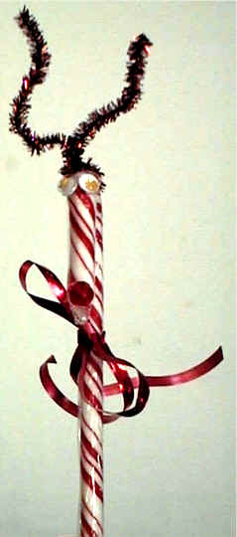
- small red beads
- red ribbon
- hot glue gun
you could try using regular white glue, but it would be a real challenge to get everything to stay stuck on.

Instructions:

Fold the pipe cleaner in half and twist it around the top of the candy cane

Bend some zig zags in both sides of the pipe cleaner to make it look more like an antler

Put a dot of hot glue where the pipe cleaner touches the candy cane to hold it in place

Hot glue the red bead to the tip of the candy cane

Hot glue the wiggly eyes just under the antlers

Finish with closing prayer.

Home time and notices.

Candy Cane:
Look at the Candy Cane
What do you see?
Stripes that are red
Like the blood shed for me.
White is for my Saviour
Who’s sinless and pure!
“J” is for Jesus My Lord that is for sure!
Turn it around
And a staff you will see
Jesus my Shepherd
Was born for Me!

Candy Cane:
Look at the Candy Cane
What do you see?
Stripes that are red
Like the blood shed for me.
White is for my Saviour
Who’s sinless and pure!
“J” is for Jesus My Lord that is for sure!
Turn it around
And a staff you will see
Jesus my Shepherd
Was born for Me!

Candy Cane:
Look at the Candy Cane
What do you see?
Stripes that are red
Like the blood shed for me.
White is for my Saviour
Who’s sinless and pure!
“J” is for Jesus My Lord that is for sure!
Turn it around
And a staff you will see
Jesus my Shepherd
Was born for Me!

Candy Cane:
Look at the Candy Cane
What do you see?
Stripes that are red
Like the blood shed for me.
White is for my Saviour
Who’s sinless and pure!
“J” is for Jesus My Lord that is for sure!
Turn it around
And a staff you will see
Jesus my Shepherd
Was born for Me!
Candy Cane:
Look at the Candy Cane
What do you see?
Stripes that are red
Like the blood shed for me.
White is for my Saviour
Who’s sinless and pure!
“J” is for Jesus My Lord that is for sure!
Turn it around
And a staff you will see
Jesus my Shepherd
Was born for Me!

Candy Cane:
Look at the Candy Cane
What do you see?
Stripes that are red
Like the blood shed for me.
White is for my Saviour
Who’s sinless and pure!
“J” is for Jesus My Lord that is for sure!
Turn it around
And a staff you will see
Jesus my Shepherd
Was born for Me!

Candy Cane:
Look at the Candy Cane
What do you see?
Stripes that are red
Like the blood shed for me.
White is for my Saviour
Who’s sinless and pure!
“J” is for Jesus My Lord that is for sure!
Turn it around
And a staff you will see
Jesus my Shepherd
Was born for Me!

Candy Cane:
Look at the Candy Cane
What do you see?
Stripes that are red
Like the blood shed for me.
White is for my Saviour
Who’s sinless and pure!
“J” is for Jesus My Lord that is for sure!
Turn it around
And a staff you will see
Jesus my Shepherd
Was born for Me

